**Communicating with RTTY**

[Sound Card Data Window](mk:@MSITStore:C:\Ham%20Radio\Logger32\Help\Draft\Logger32.chm::/SoundCardDataWindow.htm) ››

6.8 Procedure for saving an RTTY profile

**6.8.1 Using the Sound Card “MODE” menu:**

You must go thru the RTTY setup and set all the options the way you want to operate. Once you have set up the system, you must then save the profile so the system will initialize with your parameters each time you open the RTTY mode:

* 1. Open RTTY mode and set all your parameters the way you operate. Don't forget the Settings under the wrench on the control bar (MMTTY Setup);
  2. Go to Mode | Setup RTTY profiles;
  3. Select Save RTTY profile to file and follow the prompts and assign a filename. This will save the settings you just established;
  4. Repeat 2 above and select Assign RTTY Menu Item;
  5. Assign the exact name you gave the profile that you saved (without the .Pro extension); and,
  6. Click on Mode and you will now see your profile in the menu. Place a check mark by it and that will become your default profile each time you open the RTTY mode.

You can have more than one RTTY profile; just remember to assign a menu item for each one. The system will use the last checked profile the next time RTTY mode is selected.

Once you have established a profile you can also save it to a file using the menu item under "Mode | MMTTY Engine". This method will save the setup under the currently selected profile.

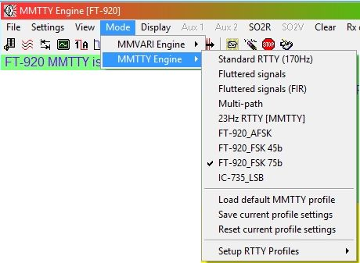

**CWR_18**

**6.8.2 Using the MMTTY “Profile” button:**

**Follow the same procedure as outlined above, using the Sound Card MODE menu.**

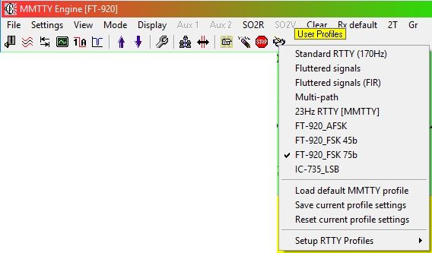

**CWR_18A**